
Setup Guide
Log Analytics Service Map

2/9/2021

Cognizant Microsoft Business Group
20 North Wacker Drive #530
Chicago, IL 60606

Notice of Confidentiality ©2021 Cognizant Microsoft Business Group All rights reserved.

IS SUBJECT TO THE TERMS OF THE COGNIZANT MICROSOFT BUSINESS GROUP NON-DISCLOSURE AGREEMENT. NEITHER THIS DOCUMENT NOR ITS CONTENTS MAY BE REVEALED OR DISCLOSED TO UNAUTHORIZED PERSONS OR SENT OUTSIDE THE AFOREMENTIONED COMPANY WITHOUT PRIOR PERMISSION FROM COGNIZANT MICROSOFT BUSINESS GROUP.

Table of Contents
Log Analytics Setup 3
Agent Install 6
Windows Machines 6
Linux Machines 9

Log Analytics Setup

- To get started, you’ll need to deploy a Log Analytics Workspace if you don’t already have an existing one to use.
  - To configure a new Log Analytics Workspace in the portal, click + Create a Resource, search for Log Analytics and then click create.

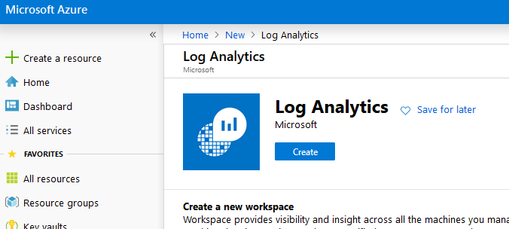

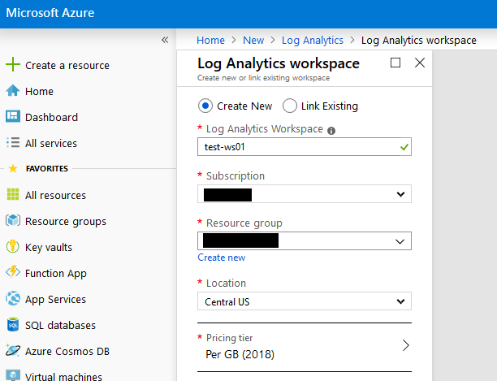

- Configure the Service Map solution.

  - To configure the Service Map solution in the portal, click + Create a Resource, search for Service Map and then click create.

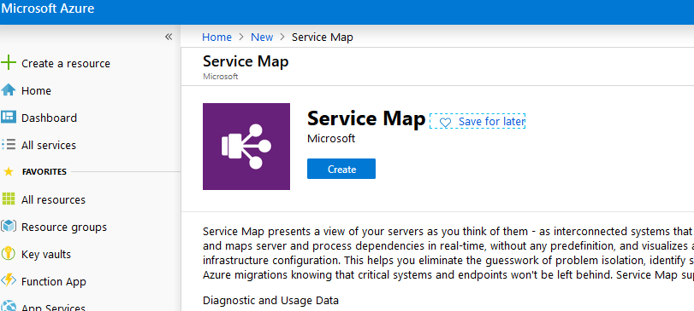

  - Select the Log Analytics workspace that you want to deploy the solution to and click Create.

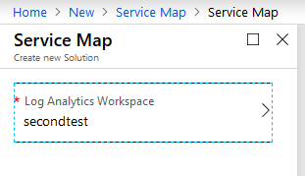

- Next, you’ll need to deploy the Log Analytics Agent and the Dependency Agent Add-On to the source machines. These are two separate installers that you can download from the Azure Portal.
- Download the Log Analytics Agent
  - Open the Log Analytics Workspace that was deployed and click Advanced Settings

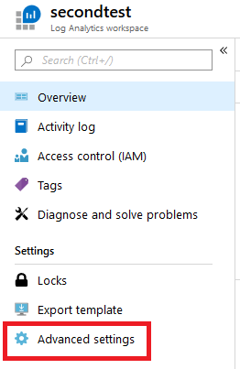

  - Note the Workspace ID and one of the keys. You’ll need these during the agent install to register the agent with the Log Analytics Workspace. Download the agent applicable to your source machines.

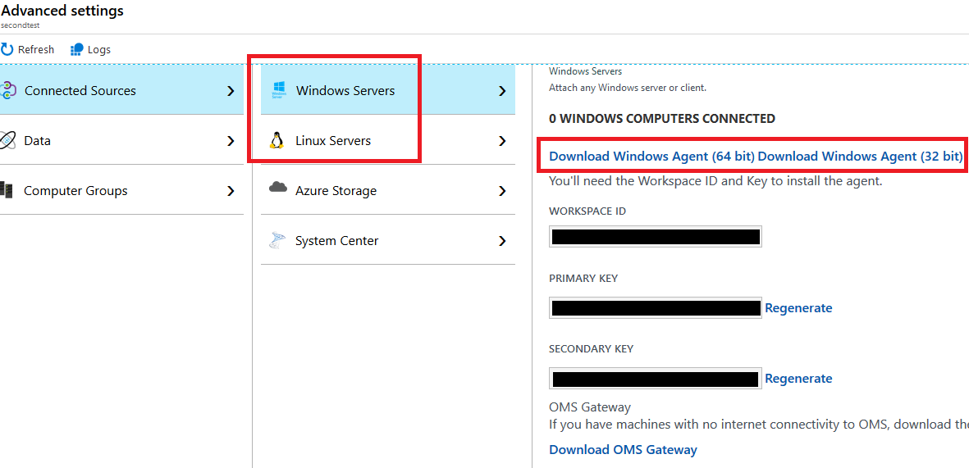

- Download the Dependency Agent
  - In the Log Analytics Workspace, click Service Map, then download the agent applicable to your source machines.

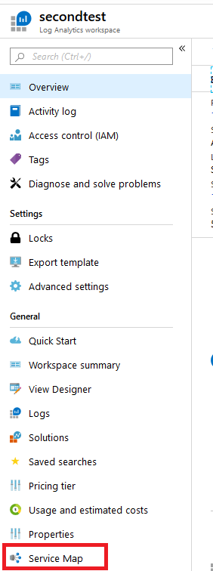

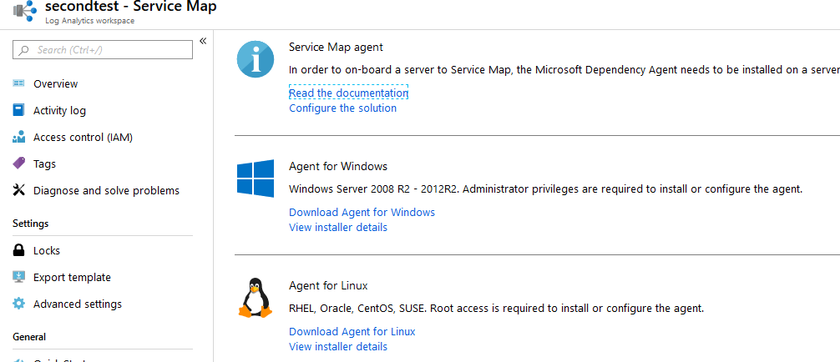

Agent Install
Now that you have the Log Analytics Workspace configured for Service Map, Workspace ID and Primary Key saved, and the agent installers downloaded, you’ll need to install the Log Analytics and Dependency Mapper agents on the source machines. This can be completed manually or through automation software like SCCM using a command line install.

Windows Machines

GUI Install
- First, run the installer for the Microsoft Monitoring Agent (aka Log Analytics Agent, MMASetup-<plaform>.exe)
- On the Welcome page, click Next
- On the License Terms page, read the license and then click I Agree
- On the Destination Folder page, change or keep the default installation folder and then click Next
- On the Agent Setup Options page, choose the Connect the agent to Azure Log Analytics (OMS) option then click Next.

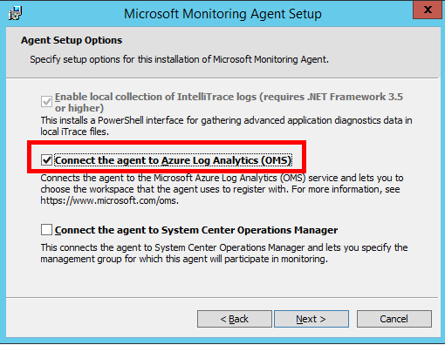

- On the Overview, Settings Dashboard page, click Connected Sources, and then copy and paste the Workspace ID and and one of the workspace keys that you saved from the portal in the previous steps.

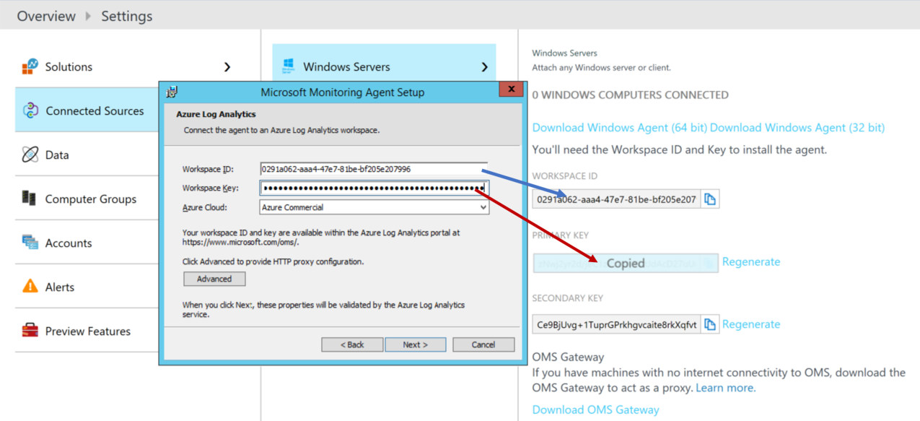

- On the Microsoft Update page, optionally select Use Microsoft Update when I check for updates (recommended), then click Next.
- On the Ready to Install page, review your choices, and then click Install.
- On the Microsoft Monitoring Agent configuration completed successfully page, click Finish.
- When complete, the Microsoft Monitoring Agent appears in Control Panel. You can verify that the agent is connected to Azure Log Analytics. When connected to Log Analytics, the agent displays a message stating: The Microsoft Monitoring Agent has successfully connected to the log analytics service.

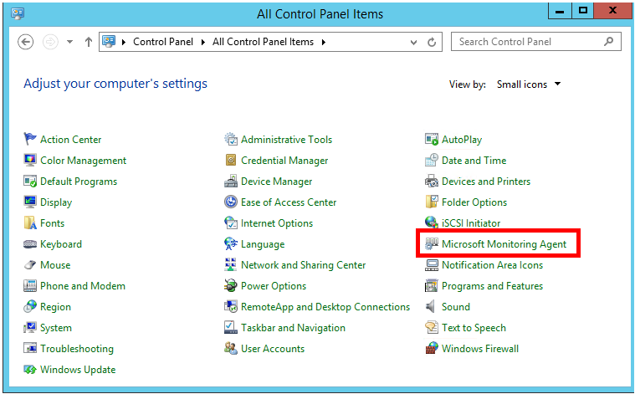
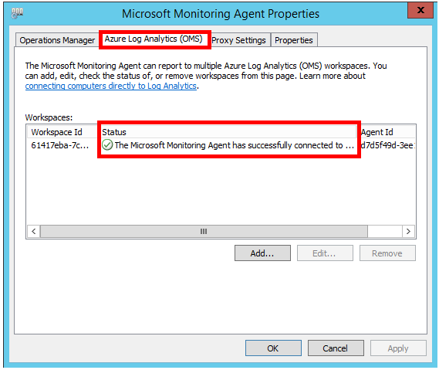

- Run the installer for the Dependcy Agent (InstallDependencyAgent-Windows.exe)
- Click I Agree to accept the license agreement
- Wait for the installer to finish, then click finish to exit the installer.

Command Line / Silent Install
- Extract the Log Analytics agent installation files. From an elevated command prompt run MMASetup-<platform>.exe /c and it will prompt you for the path to extract files to. Alternatively, you can specify the path by passing the arguments MMASetup-<platform>.exe /c /t:<Full Path>.
- To silently install the agent and configure it to report to a workspace, run setup.exe with the following options from the location in which you extracted the files, replacing the ID and Key values with those saved from the previous steps:

setup.exe /qn NOAPM=1 ADD_OPINSIGHTS_WORKSPACE=1 OPINSIGHTS_WORKSPACE_AZURE_CLOUD_TYPE=0 OPINSIGHTS_WORKSPACE_ID="<YOUR WORKSPACE ID>" OPINSIGHTS_WORKSPACE_KEY="<YOUR WORKSPACE PRIMARY KEY>" AcceptEndUserLicenseAgreement=1

- To silently install the Dependency Agent add-on, run the following command from where you stored the installer:

InstallDependencyAgent-Windows.exe /s

For more information, visit the following Microsoft documentation pages:
https://docs.microsoft.com/en-us/services-hub/health/mma-setup
https://docs.microsoft.com/en-us/azure/azure-monitor/platform/agent-windows

Linux Machines
- For the Log Analytics agent install, you have the option to use wget to download an install wrapper from GitHub. Unfortunately this is not available for the Dependency Agent, you’ll have to manually copy and install it. If you would like to also manually copy and install the Log Analytics agent with the Dependency agent, skip to step 2.

To use the Log Analytics agent installer wrapper from GitHub, run the following command providing the workspace ID and primary key copied in the previous steps. The uses wget to download the agent, validates its checksum, and then installs it.

wget https://raw.githubusercontent.com/Microsoft/OMS-Agent-for-Linux/master/installer/scripts/onboard_agent.sh && sh onboard_agent.sh -w <YOUR WORKSPACE ID> -s <YOUR WORKSPACE PRIMARY KEY>

- Copy the Azure Log Analytics and Dependency agents to the Linux machine using a tool like WinSCP.
- Log into the machine and change directory to where you placed the installers. You’ll likely need to change the permissions to make them executable. You can do this by running the chmod command. Here are example command to change directory to the temp directory where we placed the installer files and made them executable:

[root@tst-linux ~]# cd /tmp/agentinstallers/
[root@tst-linux agentinstallers]# ls
InstallDependencyAgent-Linux64.bin omsagent-1.11.0-9.universal.x64.sh
[root@tst-linux agentinstallers]# chmod +x InstallDependencyAgent-Linux64.bin omsagent-1.11.0-9.universal.x64.sh
[root@tst-linux agentinstallers]#

- Run the omsagent installer with the following command, replacing the workspace ID and Key with those copied in the previous steps:

./omsagent-<version>.universal.x64.sh --install -w <YOUR WORKSPACE ID> -s <YOUR WORKSPACE PRIMARY KEY>

- Run the dependency agent installer with the following command:

./InstallDependencyAgent-Linux64.bin
For more information, visit the following Microsoft GitHub page:
https://github.com/microsoft/OMS-Agent-for-Linux

